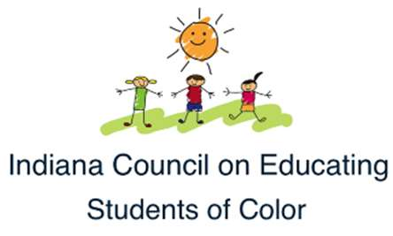
ICESC AFTER SCHOOL PROGRAM PARENT COMPACT
Circle City Prep students and the parents of these students participating in activities, services and programs provided by Indiana Council on Educating Students of Color (ICESC), agree that this compact outline how the parents and ICESC staff/support personnel will share the responsibility for improved student academic achievement. This compact provides a means by which ICESC After School Program staff, support personnel and parents can help student participants at Circle City Prep achieve the State’s high standards.
OUR COMMITMENT
Indiana Council on Educating Students of Color staff and support personnel at Circle City Prep will help to provide a high-quality curriculum and instruction in a supportive and effective environment that enables ICESC student participants to meet the State’s student performance standards. Teachers and support personnel of the ICESC After School Program will strive to do the following:
- Provide a high-quality curriculum that enables the child to meet State performance standards
- Provide parents with regular reports on their child’s progress
- Maintain open communication between parents and ICESC teachers
- Provide opportunities for parents to volunteer, participate and/or observe their child’s class
PARENT COMMITMENT

We, as parents, will support our children’s learning in ICESC’s After School Program in the following ways:

- Monitor attendance
- Make sure that homework is completed
- Monitor amount of television their children watch
- Help my child develop literacy skills (i.e., model & encourage reading, help select books, etc.)
- Promote positive use of my child’s extracurricular time
- Support the efforts of ICESC to maintain proper discipline
- Pick my child up by 6:00 PM

*Please note: Transportation will need to be provided by parents

